Special note for reader (Role doesn’t matter)
Please apologise me if you find any cosmetic error in this document. I haven’t added any cover page and etc, because I’m trying to keep this document simple and readable as much as possible. Ultimate goal of this document is to share my knowledge to reader. If you feel any difficulties to understand or want to improve this document, feel free to contact (aravinth.sivarasa@gmail.com, +61452 457 726)

“If you can't explain it simply, you don't understand it well enough “
--Albert Einstein--.

Table of Contents
Executive Summary 4
Technical skill 4
Basis Spring boot Architecture 5
Deployments and Versioning 5
Source code maintenance and Docker Registry 6
Backup and Rollback 6
Code structure 7
Code highlights 8
Testing and Audit 8
Product or Technology migration 9

Executive Summary
As a software engineer, I always desire to develop robustness application. I believe three statements in my life. 1st: "if there is a problem, there must be a solution. if not, it's a new feature to the world let's build!", 2nd:" Software is built by humans, not by aliens. Yes, we can review and enhance existing source code!" and 3rd: "Think out of the box". When we leave our ego at doorstep, can learn new things from people. I perform the icebreaker session before I start the team play. Because I believe, every team victory has a story of a wolf-pack. The following section reflects my work experience

Technical skill
Summary | Dataflow between database and end users
Language and framework | Spring Security, boot, JPA with Hibernate and JS ES6 (VUE/ Angular / React)
Host | AWS EC2 instance or on-premise (RedHat or CentOS) with docker image
Source code | Git (review code with merge request)
Development strategy | Test Driven Development

Basis Spring boot Architecture
The follow architecture consists of microservices such as admin, transaction, reporting and etc. In addition, this architecture has HA proxy (Load balancer), Eureka, API gateway (Zuul proxy) and Postgres database. Every module communicates via https and with JSON format.
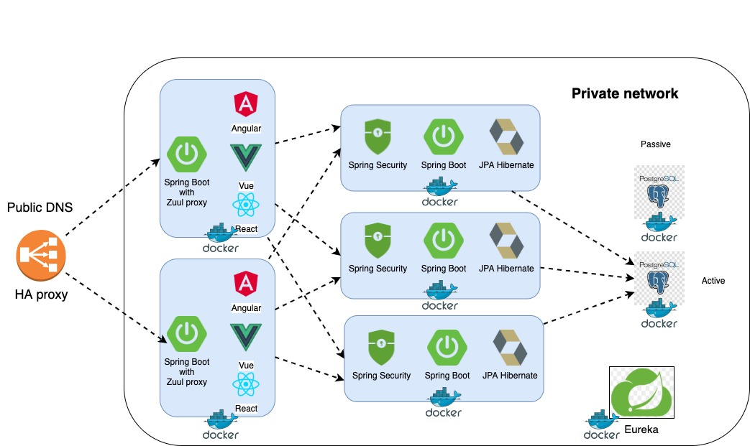
Figure 1

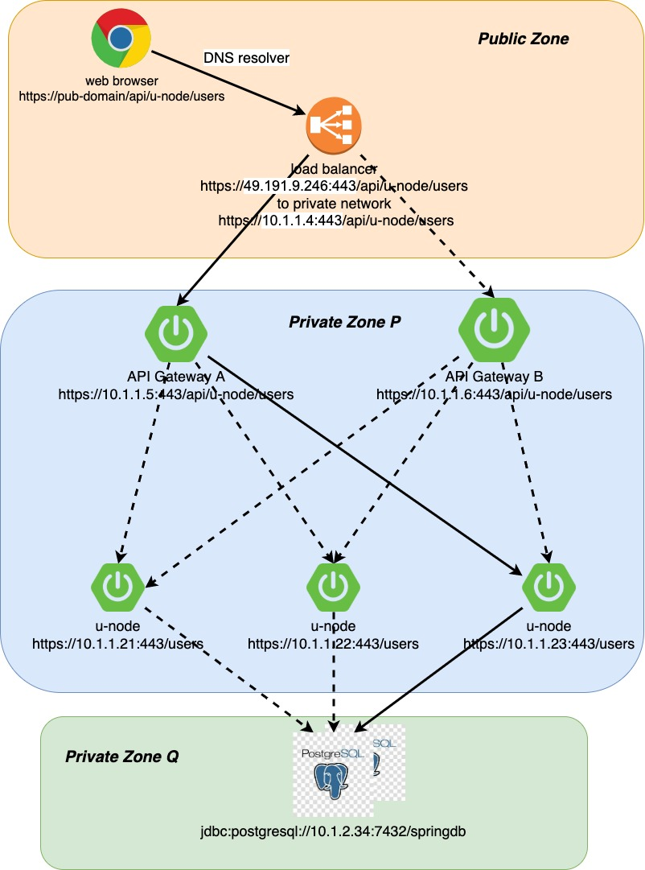
Figure 2

There are three zones in the above diagram public zone (can be accessed by public), private zone P (can be accessed by private IP 10.1.1.4) and private zone Q (can be accessed by private IP range10.1.1. *)

Deployments and Versioning
Highly recommend using semver versioning strategy, at least with two dots ex X.Y.Z
- X- major release, means deploying completely new feature
- Y- minor release, updating exiting feature
- Z- patches / bugfixes
There are many tools to achieve Continuously Integration (CI) and Continuously Deployment (CD) ex: Jenkins (preferred), Amazon Code Deploy and etc. Can be adopted based on company requirement.

Source code maintenance and Docker Registry
Highly recommend hosting all source code to git repository. Because it has many good features such as stash and etc which helps to maintain source code smoothly. Best practise in git workflow
- Master: has the source code of production release
- Branches:
  - Feature development:
  - Bugfixes
  - Deployment: contains the source code of Bugfixes or Feature development (next release)
- Tags
  - Production release
  - QA release
Once the release has been pushed to QA, source code has to be built and pushed to local docker register. Code will be pulled and deployed at QA. After verification, code will be deployed at staging and production environment.
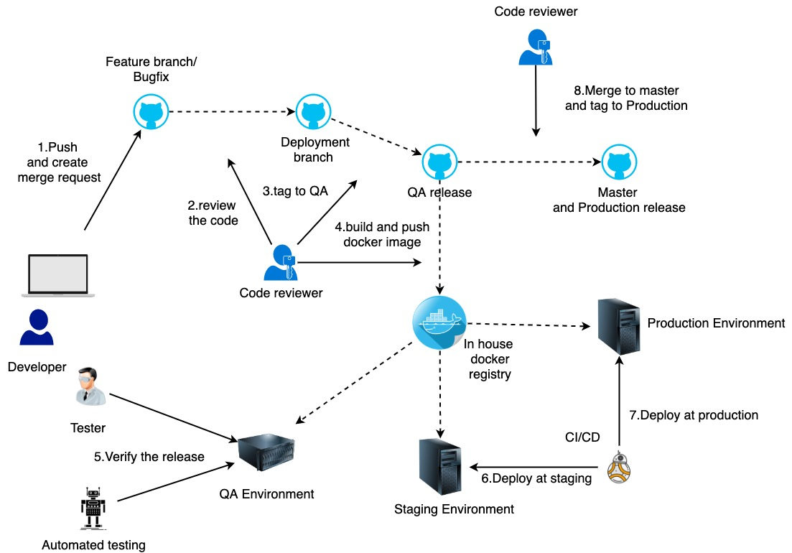
Figure 3 - above diagram staging and production environment are identical
Note: “Sonarqube will be used to verify code quality”

Backup and Rollback

If everything goes smoothly, there is no requirement for backup and rollback. Unfortunately, this code hasn’t been deployed in garden of Eden. Therefore, highly recommend having backup of database and etc before deployment. In case of emergency, can use local docker registry for rollback

Code structure

Highly recommend using build tool when starting new project. Gradle is really good tool which has nice features. On the other hand, maven has better dependency management. Therefore, prefer to use maven.

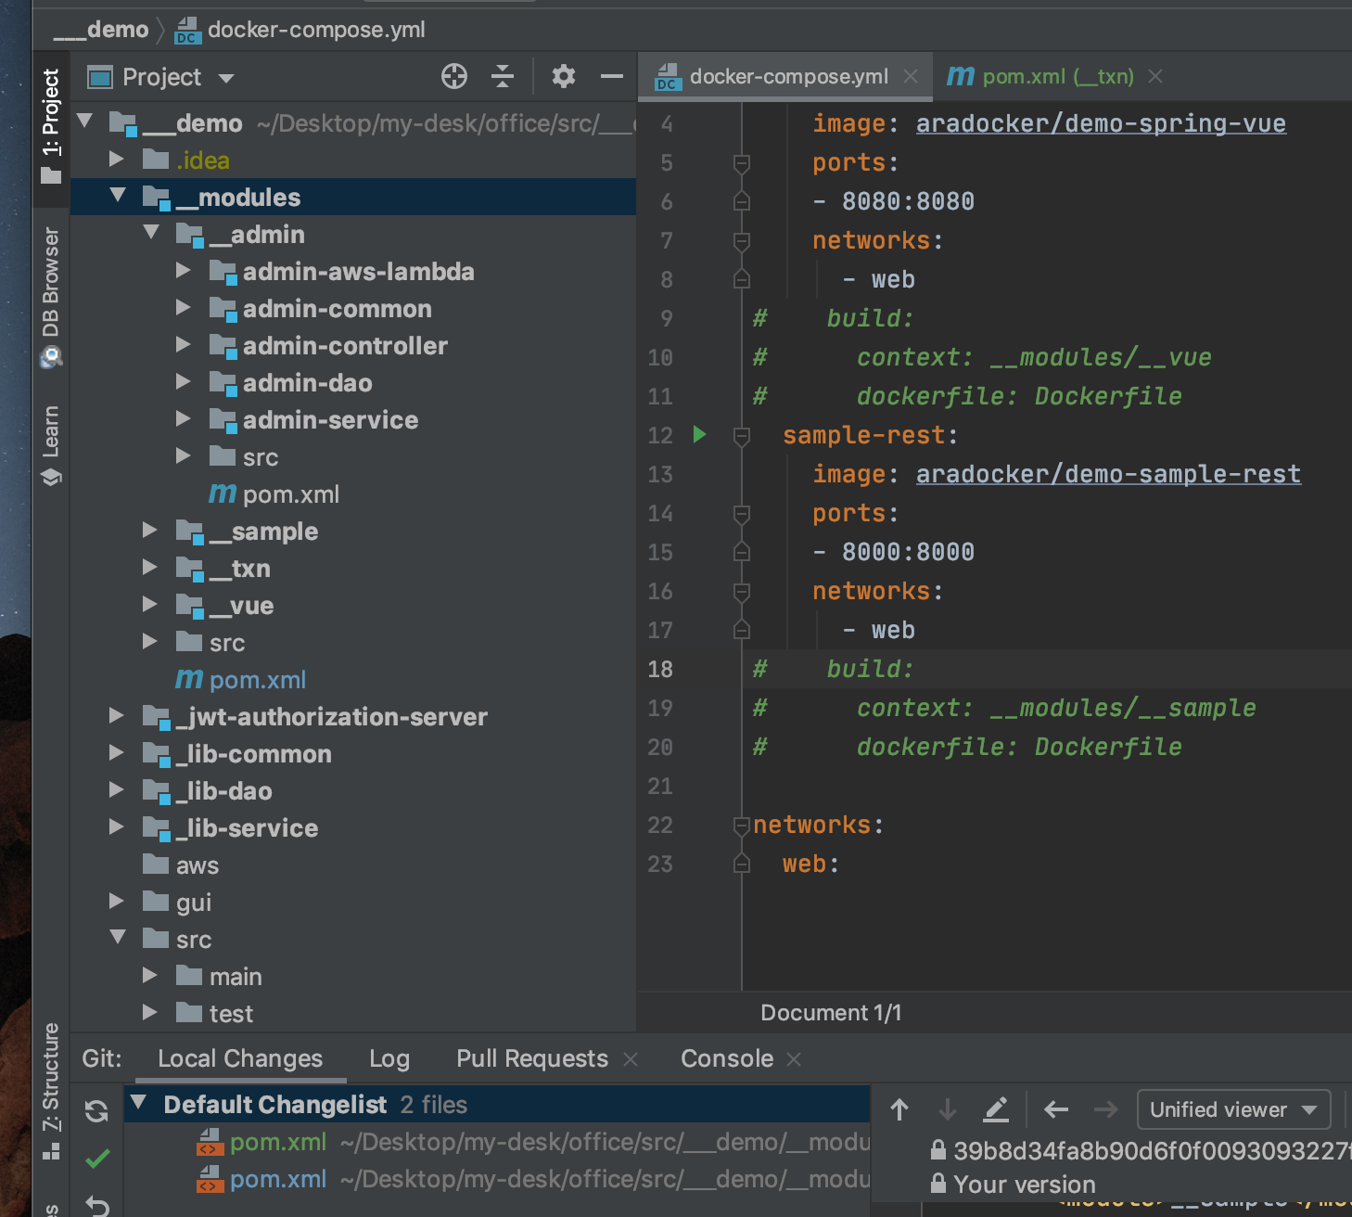
Figure 4
The above code is multi module project. Which has been derived from six years of retrospective view on code structure. Entire project falls into five layers which are
- UI: contains web interface (Vue/ Angular/ React)
- Controller: accepts all rest requests
- Service: this layer is secured by spring has two subcomponents,
  - Validations
  - Business cases
- DAO: data will be accessed via this layer, manage by JPA with Hibernate
- Common: has commonly used entities, config and etc across the layers

Code highlights
During the development there few areas developer has to focus carefully which are
- Use proper logging
- Maximum avoid loop inside loop
- Use Java 8 stream feature for iteration
- Use spring @hasPermission in service level
- Maintain static class for REST URI
- Use AuditingEntityListener for JPA audit
- Use @JsonBackReference for many to one mapping, to avoid stackoverflow error
- Use Option class to have simplified code

Testing and Audit

There are many test strategies have been followed while developing an application such as Test-Driven Development (TDD) and Behaviour Driven Development (BDD). However, each and every System Requirement Specification (SRS) or Issues should have at least minimum two test cases (success and failure). This can be achieved by Junit / Test NG / Mockito and Selenium. In addition, the following sheet has to be completed by relevant authorities to maintain the standards and Quality of application (ex CMMI, ISO and etc).
Version of Release |  |  | V1.2.1
SRS Version |  |  | V1.8
Prepared by
Reviewed by
SRS-ID | Test Type (Automated/ Manual) |  |  | Test case ID |  | Description/ test case method name |  | Status
SRS-001 | A |  |  | T- SRS-001-01 |  | fetchUser() |  | Pass
SRS-001 | A |  |  | T- SRS-001-02 |  | fetchInvalidUser() |  | Pass
IS-0012 | A |  |  | T-IS-0012-01 |  |  |  | Pass
IS-0012 |  |  |  | T-IS-0012-02 |  |  |  | Pass
Signature
Prepared by date |  | Signature of Prepared By |  |  | Reviewed by date |  | Signature of Reviewed By
Table 1
Note: “above documentation can be eliminated when we use Atlassian product”

Product or Technology migration
In digital world, migration plays major role. Because everybody wants high (throughput) efficient, secured, reliable and scalable application (Yes cost also matter !!!). Before initiate migration, highly recommend defining the scope. New technology has to satisfy the defined scope. The following table shows technology migration in my career.
Specification |  | Year
 |  | 2013 | 2014-2016 | 2017 | 2018-2020+
Reliable Language |  | Java 6 | Java 7 | Java 8 | Java 8
Framework | Memory management and security | Spring 3 | Spring 3 | Spring boot (Spring 5+) | Spring boot2  (Spring 5+)
 | ORM | JPA with Hibernate | JPA with Hibernate | JPA with Hibernate | JPA with Hibernate
Build Tool | Test | Ant | Maven | Maven | Maven (Gradle)
 | Dependency management
UI | Input Text | JSF ice face | JSF prime face, JSP | HTML5 + JSF, AngularJS | Vue (Angular and React)
UI | Data submission
UI | Popups
UI | Data table
Servers | Hosting | CentOS | RedHat | RedHat | Docker (Java alpine)
Database |  | MySql | Oracle | Oracle/ MySql/Postgres | Oracle/ MySql/Postgres
Version tool |  | SVN | SVN | git | git
Table 2
When it comes to product migration. User experience, impression and usability play key roles in costing. The following diagram shows basic migration strategy. Good design and implementation should reduce mt
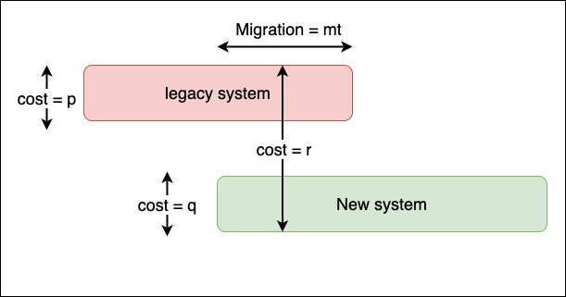
Figure 5

